Computational Fluid Dynamics

Ex2

Almog Dobrescu

214254252

# Table of Contents

Table of Contents 1

List of Figures 2

Project Objective 3

Governing Equations 3

Euler Equations 3

Transforming the Equations to Curvilinear Coordinates 5

Contravariant Velocities 7

The Numerical Scheme 8

Beam & Warming Algorithm 8

Convergence Condition 11

Boundary Conditions – Implementation on a Computational Mesh 11

Functional Description 13

Flow Chart 13

The functions in the program 13

Results 14

14

17

Effect of Time Step on Results for 20

Effect of Time Step on Results for 22

Conclusions 24

# List of Figures

Figure 1: Wall BC 11

Figure 2: Flow field for 14

Figure 3: Flow field for - zoom 14

Figure 4: Convergence history for 15

Figure 5: Mach distribution on the airfoil for 15

Figure 6: Pressure distribution on the airfoil for 16

Figure 7: Flow field for 17

Figure 8: Flow field for - zoom 17

Figure 9: Convergence history for 18

Figure 10: Mach distribution on the airfoil for 18

Figure 11: Pressure distribution on the airfoil for 1.5 19

Figure 12: Effect of time step on convergence history for 20

Figure 13: Effect of time step on Mach distribution for 20

Figure 14: Effect of time step on pressure distribution for 21

Figure 15: Effect of time step on convergence history for 22

Figure 16: Effect of time step on Mach distribution for 22

Figure 17: Effect of time step on pressure distribution for 23

# Project Objective

Writing a general computer program to solve the Euler equations for a two-dimensional flow in curvilinear coordinates using the Beam & Warming algorithm (using the Euler implicit, first order temporal accuracy, scheme).

# Governing Equations

## Euler Equations

### Navier-Stokes Equations

Conservation of mass:

|  |  |  |
| --- | --- | --- |
|  |  | () |

Conservation of momentum:

|  |  |  |
| --- | --- | --- |
|  |  | () |

Where the stress tensor for homogeneous, isotropic and Newtonian fluid is:

|  |  |  |
| --- | --- | --- |
|  |  | () |

Conservation of energy:

|  |  |  |
| --- | --- | --- |
|  |  | () |

Where:

|  |  |  |  |  |
| --- | --- | --- | --- | --- |
|  | Energy |  |  | () |
|  | Heat (Fourier's law) |  |  | () |
|  | External heat source |  |  | () |
|  | Body forces |  |  | () |

The compact form of the Navier Stokes equations:

|  |  |  |
| --- | --- | --- |
|  |  | () |

Where:

|  |  |  |  |  |  |
| --- | --- | --- | --- | --- | --- |
|  |  |  |  |  | () |

The viscous terms:

|  |  |  |  |  |  |  |
| --- | --- | --- | --- | --- | --- | --- |
|  | |  |  |  | | () |
|  |  | | | |  | () |
|  |
|  |  | | | |
|  |  | | | |
|  |  | | | |
|  |  | | | |
|  |  | | | |
|  |  | | | |
|  |  | | | |
|  |  | | | |

### Euler Equations

The assumptions:

* Viscous and heat conduction effects are negligible compared to the inertial forces.
* Dropping all terms associated with and since

Therefor the equations take the form:

|  |  |  |
| --- | --- | --- |
|  |  | () |

## Transforming the Equations to Curvilinear Coordinates

In two dimensions, the Euler equations take the form:

|  |  |  |
| --- | --- | --- |
|  |  | () |

Where:

|  |  |  |  |  |
| --- | --- | --- | --- | --- |
|  |  |  |  | () |

The generalized transformation in 2-D:

|  |  |  |  |
| --- | --- | --- | --- |
|  |  |  | () |

The chain rule is given by:

|  |  |  |
| --- | --- | --- |
|  |  | () |

Applying the chain rule results in:

|  |  |  |
| --- | --- | --- |
|  |  | () |

Multiply by and rewrite as follows:

|  |  |  |
| --- | --- | --- |
|  |  | () |

Where is the Jacobian

|  |  |  |
| --- | --- | --- |
|  |  | () |

Applying the above relation on all terms:

|  |  |  |
| --- | --- | --- |
|  |  | () |

Note:

|  |  |  |  |  |  |
| --- | --- | --- | --- | --- | --- |
|  |  |  |  |  | () |

Rearrange and substitute:

|  |  |  |
| --- | --- | --- |
|  |  | () |

Similarly:

|  |  |  |
| --- | --- | --- |
|  |  | () |

The transformed equations therefore take the form:

|  |  |  |
| --- | --- | --- |
|  |  | () |

Where:

|  |  |  |
| --- | --- | --- |
|  |  | () |

In our case, the mesh is fixed in time so:

|  |  |  |
| --- | --- | --- |
|  |  | () |

## Contravariant Velocities

The velocities in the computational coordinate direction, and :

|  |  |  |
| --- | --- | --- |
|  |  | () |

The inviscid rotated fluxes therefore take the form:

|  |  |  |  |
| --- | --- | --- | --- |
|  |  |  | () |

# The Numerical Scheme

## Beam & Warming Algorithm

Utilize trapezoidal integration and forward differencing in time (second order in time):

|  |  |  |
| --- | --- | --- |
|  |  | () |

Both and are non-linear functions of and therefore linearization is required prior to the evaluation of the spatial differences:

|  |  |  |
| --- | --- | --- |
|  |  | (*)* |

Where:

|  |  |  |
| --- | --- | --- |
|  |  | () |
|  |  | () | |

Applying the Taylor series expansion:

|  |  |  |
| --- | --- | --- |
|  |  | () |

Therefore:

|  |  |  |
| --- | --- | --- |
|  |  | () |

Substitution of the Taylor series expansion results in (delta form):

|  |  |  |
| --- | --- | --- |
|  |  | () |

The first order implicit Euler scheme is given by:

|  |  |  |
| --- | --- | --- |
|  |  | () |

Beam and Warming uses central differencing for the spatial derivative approximations, resulting in (implicit Euler):

|  |  |  |
| --- | --- | --- |
|  |  | () |

Where:

|  |  |  |
| --- | --- | --- |
|  |  | () |

After applying artificial smoothing:

|  |  |  |
| --- | --- | --- |
|  |  | () |

The implicit scheme requires inversion of a block penta-diagonal matrix with blocks (block hepta-diagonal matrix with blocks in 3-D). The required inversion is costly and therefore approximate factorization is applied as follows (implicit Euler):

|  |  |  |
| --- | --- | --- |
|  |  | () |

In our case:

|  |  |  |  |  |
| --- | --- | --- | --- | --- |
|  |  |  |  | () |

### Beam & Warming – Solution Procedure

Define:

|  |  |  |
| --- | --- | --- |
|  |  | () |

Solve:

|  |  |  |
| --- | --- | --- |
|  |  | () |

Solve:

|  |  |  |
| --- | --- | --- |
|  |  | () |

Advance:

|  |  |  |
| --- | --- | --- |
|  |  | () |

Returning to the physical domain:

|  |  |  |
| --- | --- | --- |
|  |  | () |

Each factor is a series of block tridiagonal line inversions, e.g. the coordinate direction linear system:

|  |  |  |
| --- | --- | --- |
|  |  | () |

The coordinate direction linear system:

|  |  |  |
| --- | --- | --- |
|  |  | () |

## Convergence Condition

The convergence criterion is the norm of .

When drops 6 orders of magnitude, the solution is considered converged.

## Boundary Conditions – Implementation on a Computational Mesh

### Wall BC

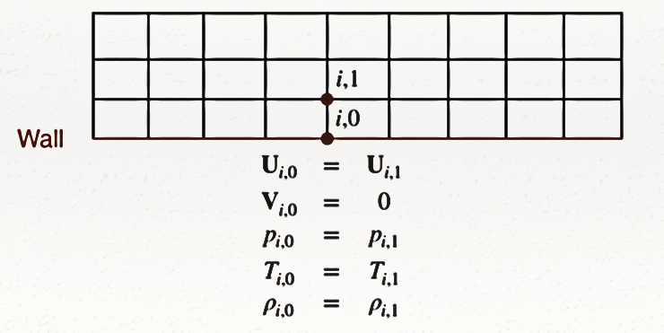Inviscid flow, adiabatic wall boundary conditions in 2-D – Finite differences:

Figure 1: Wall BC

|  |  |  |
| --- | --- | --- |
|  |  | () |

Isolating and :

|  |  |  |
| --- | --- | --- |
|  |  | () |

|  |  |  |
| --- | --- | --- |
|  |  | () |

|  |  |  |
| --- | --- | --- |
|  |  | () |

|  |  |  |
| --- | --- | --- |
|  |  | () |

### Trailing Edge BC

Applying the Kutta condition:

|  |  |  |
| --- | --- | --- |
|  |  | () |
|  |  | () |
|  |  | () |
|  |  |  |
|  |  | () |

|  |  |  |
| --- | --- | --- |
|  |  | () |

### Cut BC

Applying simple averaging of the vector along the wake:

|  |  |  |
| --- | --- | --- |
|  |  | () |
|  |  |  |
|  |  | () |

### Outflow

Applying simple extrapolation:

|  |  |  |
| --- | --- | --- |
|  |  | () |

# Functional Description

## Flow Chart

## The functions in the program

The functions that are included in the program and explanation about them are included in the code itself.

# Results

## 

### Flow field

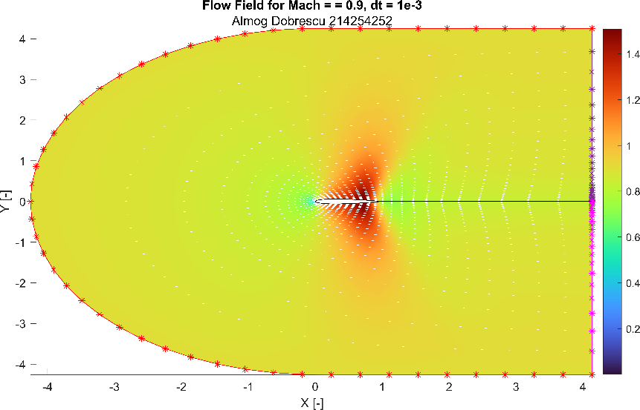

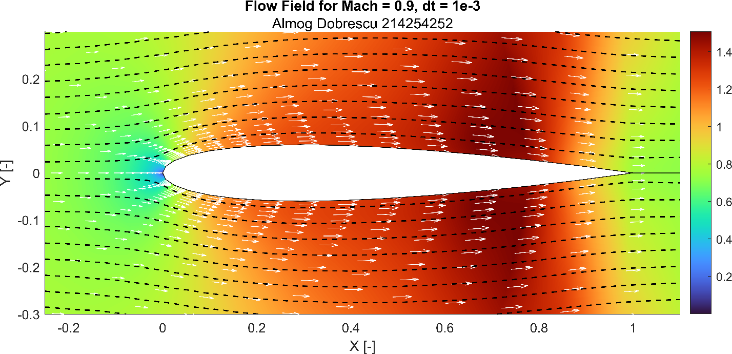

Figure 2: Flow field for - zoom

Figure 3: Flow field for

We can see that an expansion fan is forming near the trailing edge and the flow field is symmetric

### Convergence history

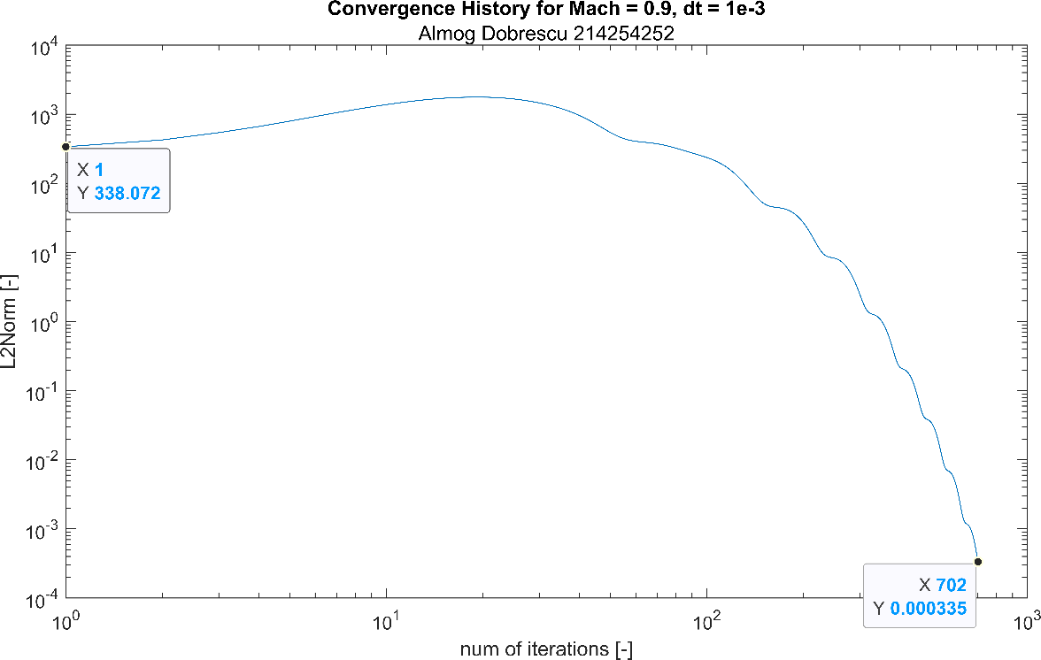

Figure 4: Convergence history for

We can see that at first the flow field changes rapidly and slowly start to stabilize around a solution. In this case, it took 702 iterations before L2Norm drops 6 orders of magnitude.

### Mach distribution on the airfoil

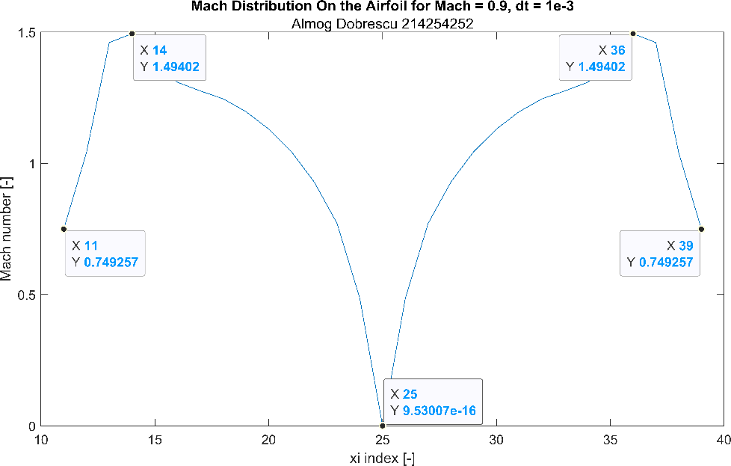

Figure 5: Mach distribution on the airfoil for

We can see that the Mach distribution is symmetric around the leading edge, as expected because the angle of attack is zero. Moreover, the Mach number at the trailing edge is lower than at infinity.

### Pressure distribution on the airfoil

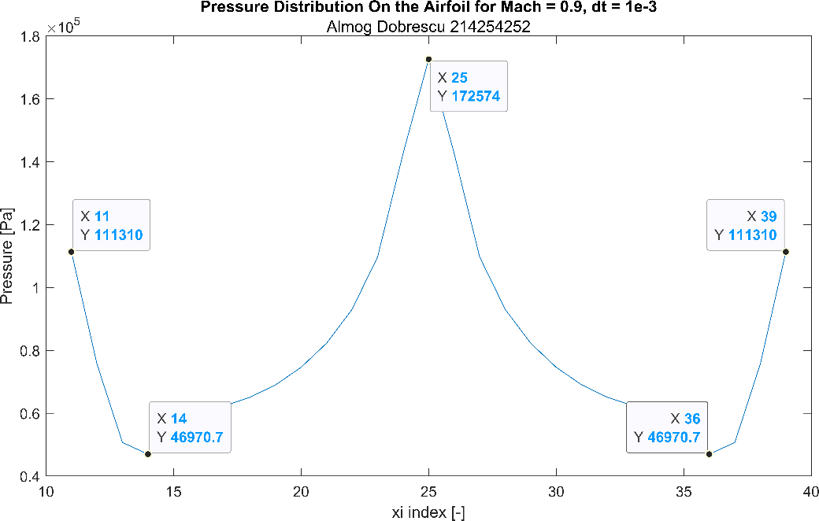

Figure 6: Pressure distribution on the airfoil for

We can see that the pressure distribution is symmetric around the leading edge, as expected because the angle of attack is zero. Moreover, the pressure distribution is exactly inverse to the Mach distribution and the maximal pressure is at the leading edge.

### Flow field

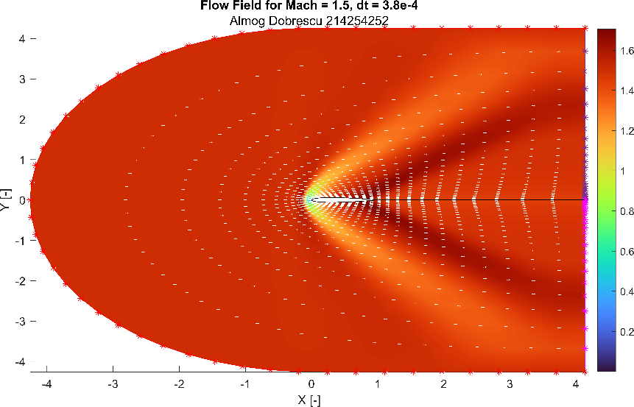

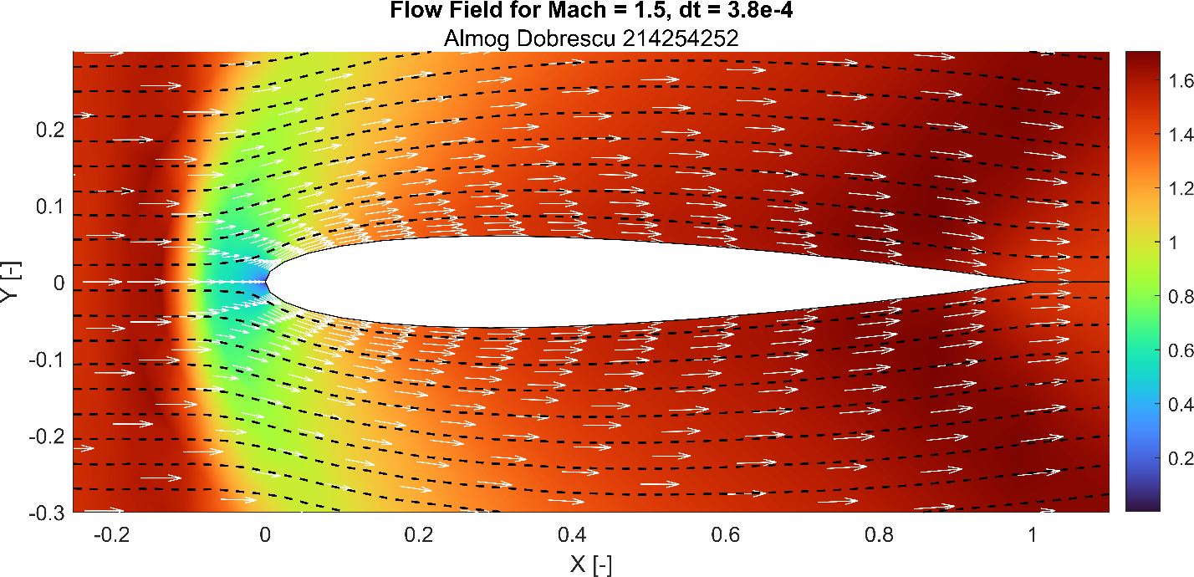

Figure 7: Flow field for

Figure 8: Flow field for - zoom

We can see a detached shock wave in front of the leading edge of the airfoil. Moreover, the angle of the expansion fan near the trailing edge is smaller in comparison to the expansion fan in seen in Figure 3.

### Convergence history

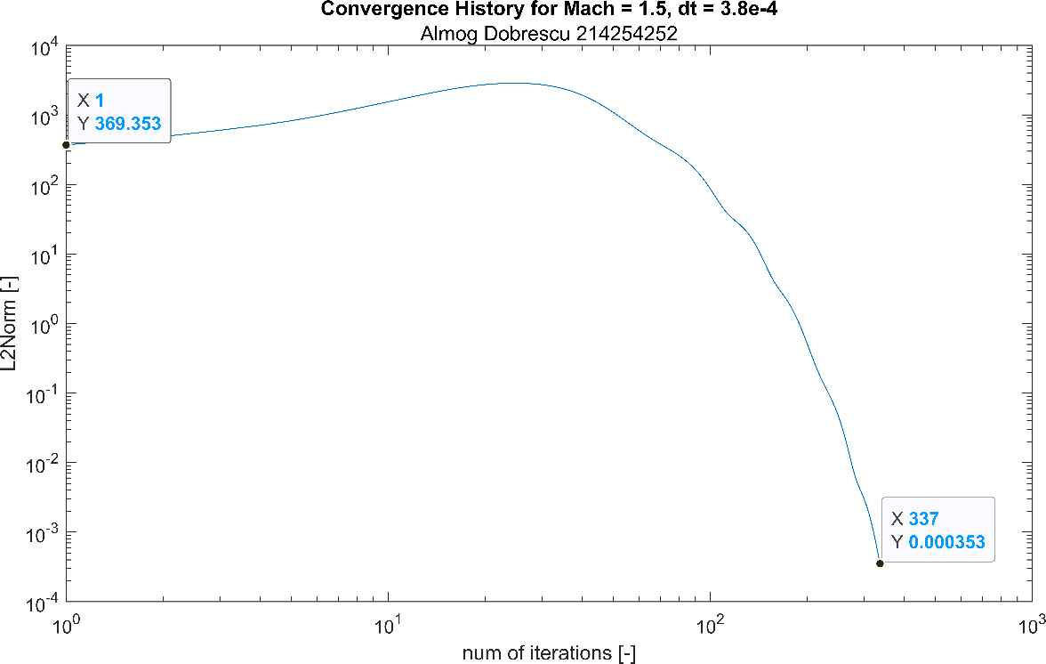

Figure 9: Convergence history for

We can see that at first the flow field changes rapidly and slowly start to stabilize around a solution. In this case, it took 339 iterations before L2Norm drops 6 orders of magnitude.

### Mach distribution on the airfoil

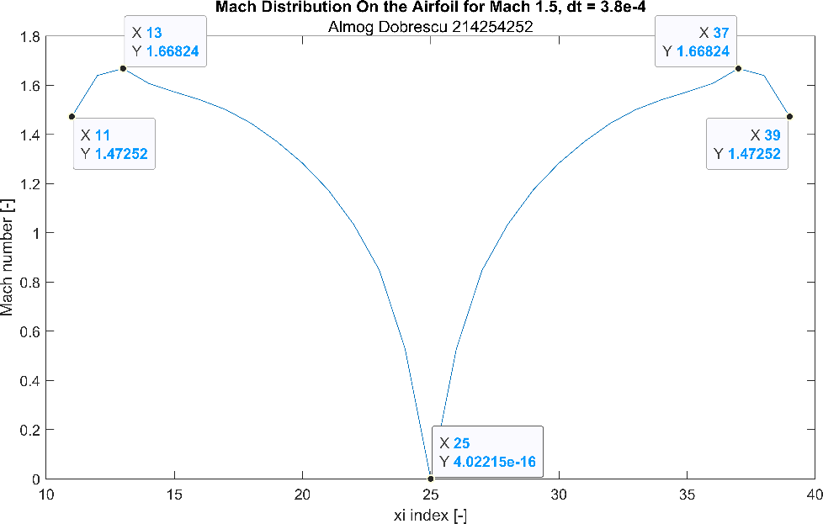

Figure 10: Mach distribution on the airfoil for

We can see that the Mach distribution is symmetric around the leading edge, as expected because the angle of attack is zero. Moreover, the Mach number at the trailing edge is lower than at infinity.

### Pressure distribution on the airfoil

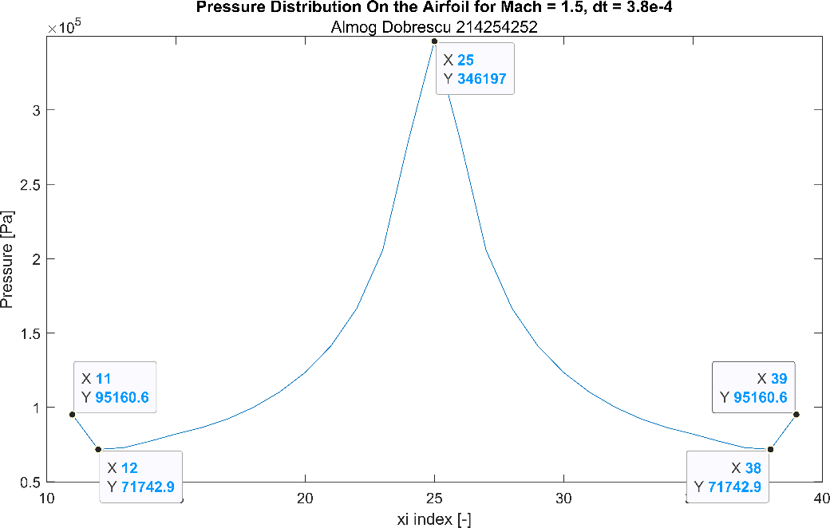

Figure 11: Pressure distribution on the airfoil for 1.5

We can see that the pressure distribution is symmetric around the leading edge, as expected because the angle of attack is zero. Moreover, the pressure distribution is almost exactly inverse to the Mach distribution and the maximal pressure is at the leading edge.

## Effect of Time Step on Results for

### Convergence History

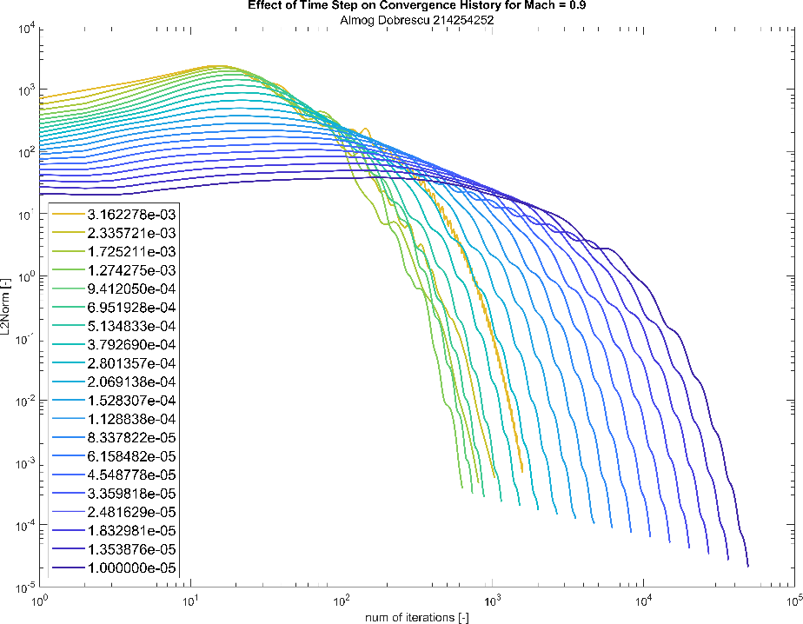

Figure 12: Effect of time step on convergence history for

We can see that there is an optimal for whom the number of iterations is minimal.

Below that the solver becomes quite unstable.

### Mach distribution on the airfoil

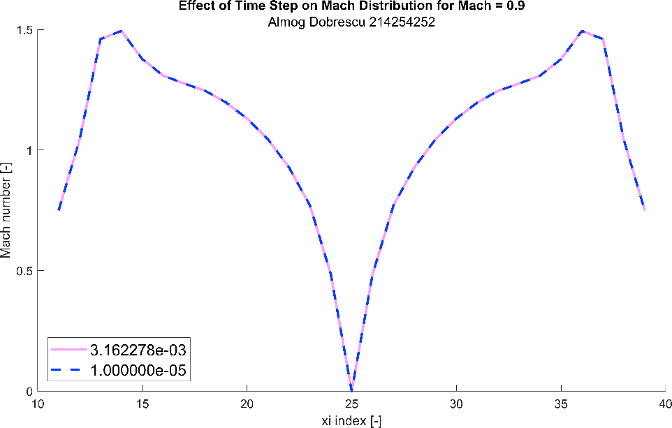

Figure 13: Effect of time step on Mach distribution for

We can see that there is no difference in the Mach distribution on the airfoil for difference .

### Pressure distribution on the airfoil

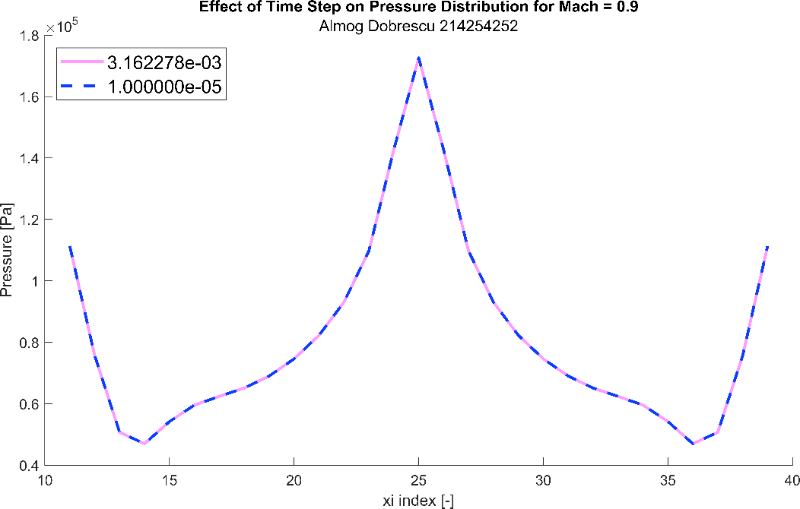

Figure 14: Effect of time step on pressure distribution for

We can see that there is no difference in the pressure distribution on the airfoil for difference .

## Effect of Time Step on Results for

### Convergence History

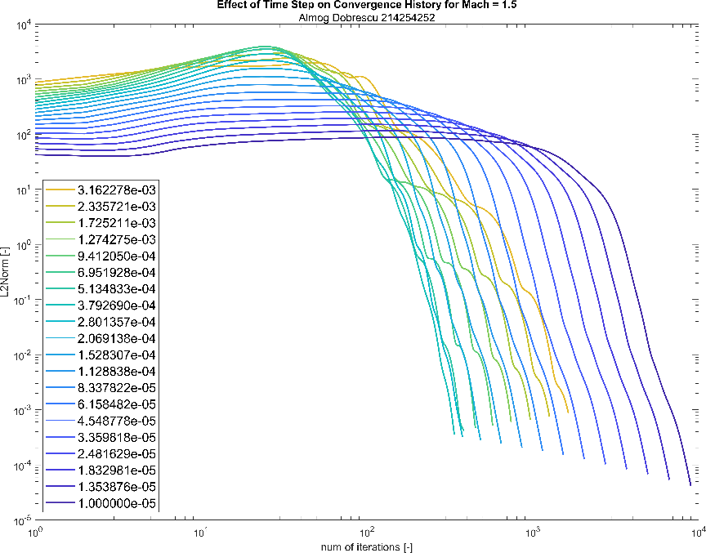

Figure 15: Effect of time step on convergence history for

We can see that there is an optimal for whom the number of iterations is minimal.

Below that the solver becomes quite unstable.

### Mach distribution on the airfoil

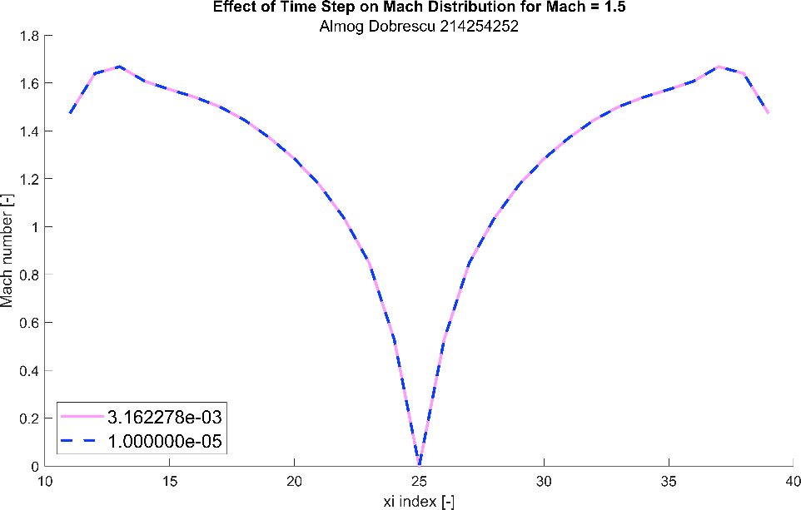

Figure 16: Effect of time step on Mach distribution for

We can see that there is no difference in the Mach distribution on the airfoil for difference .

### Pressure distribution on the airfoil

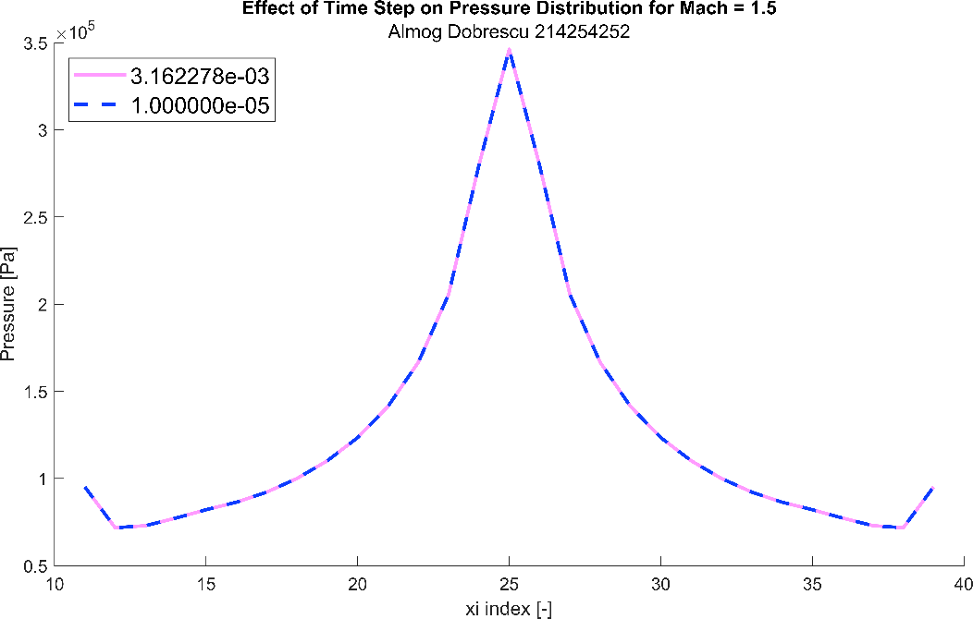

Figure 17: Effect of time step on pressure distribution for

We can see that there is no difference in the pressure distribution on the airfoil for difference .

# Conclusions

* The time step, , does not change the final qualitative and quantitative results (in the range of , for ), as seen in Figure 13, Figure 14, Figure 16 and Figure 17.
* For different values, there is a different optimal for minimal number of iterations, as shown in Figure 12 and Figure 15.
* The pressure and the Mach number are anti-symmetric to each other. This fact can be observed in the pairs of figures: Figure 5, Figure 6 and Figure 10, Figure 11.
* When the angel of attack is zero, the velocity (Mach number) is indeed zero at the leading edge. It can be clearly seen in Figure 3 and Figure 8.
* As the grows, the solver can "handle" bigger time steps () as seen in the differences between figures Figure 12 and Figure 15.
* As grows, the expansion fan occurs later (closer to the trailing edge). This can be seen in the difference between Figure 5 and Figure 10